An Association Study on the Aesthetic Characteristics of Digital Lighting and Impressionist Painting
-- Taking "Zootopia" as an example

Guochao Sha, Donghyuk Choi
Department of Visual Contents, Division of Digital Contents
Graduate School of Dongseo University, Dongseo University
Busan, South Korea
yirenzhizha@gmail.com, artistar@dongseo.ac.kr

Abstract

Light leads people to feel all things on earth, and can make people experience the time and space. The intensive study of light in the nineteenth Century led to the understanding of the relationship between light and color and promoted the creation of Impressionism. Impressionist painters focused their efforts on capturing visual impressions and the pursuit of light color changes, focusing on the visual perception of the work which is a great boost to human aesthetics.The act of lighting and shadow manipulation is called 'lighting'. Using this action, the color effect of light has been shown in many media such as photography, drama, film and animation.Different from the actual illumination, the lighting technology in 3D animation needs to pursue the effect of the picture, so that the audience can understand the plot and emotional expression of the animated cartoon. However, only by ordinary lighting techniques, the mood in the three-dimensional animation narrative scene is limited.The lighting in 3D animation needs to be exaggerated which depending on the subjective features of the story, the color, and brightness of the light. This is in line with the pursuit of impressionist painting color effect, emphasizing the aesthetic features of painting coincide.In this study, based on the analysis of impressionist painting features, and the found in the three-dimensional animation of the narrative scene emotional lighting Association, in order to make lighting more suitable for three-dimensional animation. Expecting this research to become a benchmark for expressing emotions in 3D animation.

Keywords： Impressionism; 3D animation; light

I. Introduction

The manualoperation of light and shadow is called ‘illumination’, in photography, drama, film, animation and other media, illumination shows the light and color effects required by the work. The digital lighting in 3D animation movies is different from the actual lighting, for the pursuit of a good picture, animation lights are artificially exaggerated light and color effects, but also to let the audience to feel the emotion and understanding of the plot.
In the field of art, the same attention to the effect of light and shadow is the emergence of Impressionism in nineteenth Century. Because this in-depth study of light generated in the painting art school, featured by capturing the visual impression and pursuing the color of light and shadow, and paying attention to the visual perception of the work.
Based on Impressionist paintings, as well as on the three-dimensional animation film lighting analysis of “Zootpia”, this paper summarizes the aesthetic characteristics of impressionist painting and the lighting characteristics of the emotional expression of the narrative scene in the three dimensional animated film, so as to find the correlation. The ultimate purpose is to understand the use of Impressionist lighting settings for the development of three-dimensional animation film and the specific role of emotional expression. We expect this research data to be an important research material for the development and lighting techniques of many image content.

II. Principal Argument

- The characteristics of Impressionism and Impressionist

In the nineteenth century, the in-depth study of light has enabled people to understand the relationship between light and color, and promote the generation of Impressionism. Impressionist painting is the transition from western traditional painting to modern painting, which not only completely changes the color concept of the painters who treat the objective objects, but also changes the concept of the theme. Impressionist painting has made many progress, also exposed its limitations, but it broke through the shackles of the Renaissance tradition, broke the old concept of painting, leading the western painting entering into a new era, and creating conditions for the development of modern fine arts.
Impressionist painters oppose the conservative ideology and expression of the academy, against the stereotypes of religious mythology and the grayish tones following an old routine. They vividly represent the daily life scene and beautiful natural scenery, and capture all kinds of vivid life impression. They focus their energies on exploring the expression of light and color, emphasizing subjective feelings, instant impressions and general atmosphere, not paying much attention to painting plots or painting techniques, and emphasizing personal style. They applied the principle of optics to painting, negating the concept of color fixation, emphasizing the color of light source, condition color, and less use of black; instead of the traditional light and shade, the color of cold and warm contrast is used to capture the fast changing light color effect, they mostly paint with small strokes, and they have smaller size of a picture. For impressionist painters, painting beauty lies not in the object itself, but in the rich color changes in the sun.[1]

B. Characteristic examples of impressionist painting

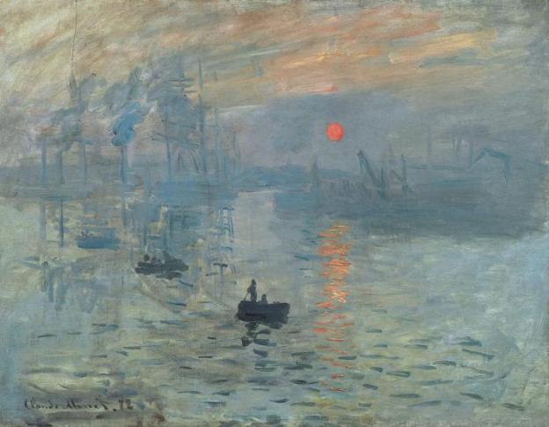
Fig 1 Monnai Impression, Sunrise

Impressionist paintings fully show the painter's maturity of the way of observing nature, who pay attention to observation and capture of light moment under the change of color.
As shown in Figure 1, "Impression, Sunrise" is an extremely important representative work of Impressionism, and also an important masterpiece of Monet's impressionistic style. This is a very clear display of Monet's ability to capture the unique color changes in the instantaneous light conditions, the use of color relations color relations to make the picture full of strong artistic appeal.[2]

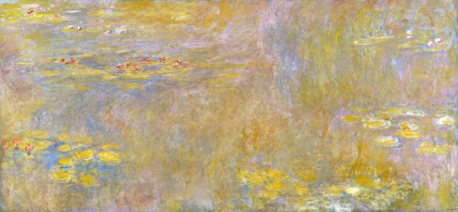
Fig. 2Monnai “Le Bassinaux Nympheas”
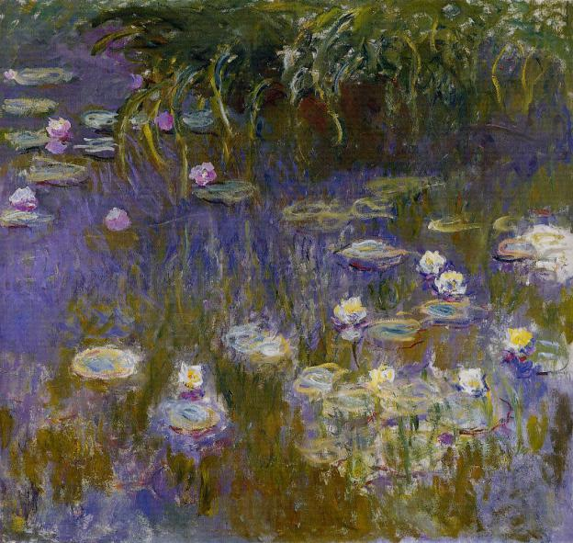
Fig. 3 Monnai “Le Bassinaux Nympheas”

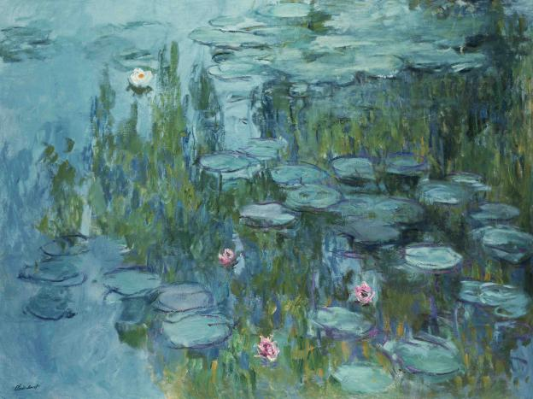
Fig. 4 Monnai “Le Bassinaux Nympheas”


Fig. 5 Monnai “Le Bassinaux Nympheas”

“Le Bassinaux Nympheas” is the representative of Impressionist. These “Le Bassinaux Nympheas” have different styles, different strokes, and the most important difference - the color difference between light and shadow provides the spectator with different psychological feelings.

C. The effect of color on emotions

In the book of “Color psychology”, the author gives a detailed introduction to the characteristics of color. In the chapter of color warming and cooling, it is said that the external objects can give people warmth or cold or cool feeling through the surface color, in general, the temperature sensation is through the sensory organ touch objects, and have nothing in common with color. But the fact is that all kinds of objects do give people a certain temperature feeling with colorful colors.
Color | RGB | Association | Effect | Colour system
Red | 255  0  0 | Sun  Blaze | Give people a positive, energetic, warm feeling | Warm color
Orange | 255  128  0 | Sun  Blaze | Give people a positive, energetic, warm feeling | Warm color
Yellow | 255  255  0 | Sun  Blaze | Give people a positive, energetic, warm feeling | Warm color
Cyan | 0  255  255 | Dark night  Clod | Give people a quiet, negative feeling | Cool color
Blue | 0  0  255 | Dark night  Clod | Give people a quiet, negative feeling | Cool color
Green | 0  255  0 | Grass  Mystery | Make people relaxed and comfortable | Intermediate color
Purple | 255  0  255 | Grass  Mystery | Make people relaxed and comfortable | Intermediate color
Red,orange and other colors make people think of the sun, fire, so called "warm color". blue, green and other color is associated with the night and cold, thus called “cool color”, red expresses a positive, Yue move, warm feeling, blue gives people a quiet and passive feeling. Green and purple is a neutral color, little stimulation between the effect between red and blue. Intermediate colors make people open and relax, and they can avoid fatigue.[3] According to the conceptual descriptions in the book, they are arranged in tabular form, as shown in table 1.

TABLE 1 COLOUR AND EMOTION

D. Analysis of the Characteristics of Lighting in "Zootopia"

The object of this study is "Zootopia", which won the best animated film of Oscar in 2016, the picture is excellent, the plot is rich in reverse, with full three-dimensional shaping, and well placed emotional communication. And the film also featured with good lighting, lighting the superior picture, gave the audience a good visual experience. The emotion conveyed to the audience makes the story stronger. These features make people reminiscent of impressionist painting features.

TABLE2
ANALYSIS OF THE CHARACTERISTICS OF LIGHTING

Screenshot | Extract color | RGB | Color system
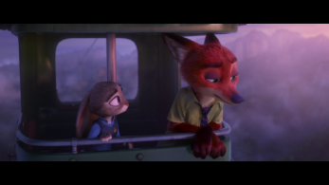 |  | 193  140  180 | Cool color
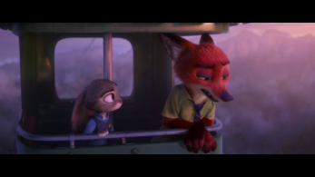 |  | 226  164  174 | Cool color
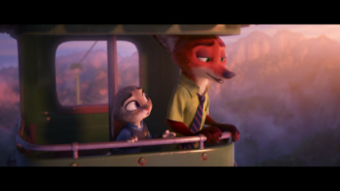 |  | 232  164  150 | Warm color
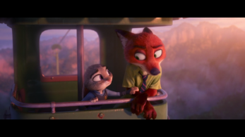 |  | 241  165  150 | Warm color
In the movie, the protagonists witness failure in pursuit of the rainforest, and then two characters took the cable car to leave. In this episode, the first rabbit police officer of zootopia,Judy Hopps helps the swindlers foxes Nick Wilde break away from childhood psychological shadow, as the story goes bright and warm, the color of the background changes.
The Nick is grieved and sad, the tone of the picture is cold, bluish violet in general, the sun has not yet risen; when the Nick is getting better, the hue of the picture is warming, orange red in general, and the sun is rising gradually. The director uses the theory of color psychology to combine the feeling of color with the plot and the mood of the characters. The use of color to express emotions conforms to the characteristics of impressionist painting. As shown in table 2.

TABLE3
ANALYSIS OF THE CHARACTERISTICS OF LIGHTING

Screenshot | Extract color | RGB | Color system
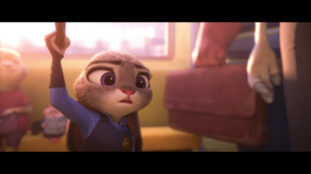 |  | 141  99  91 | Warm color
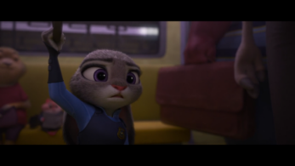 |  | 46  34  34 | Cool color
As shown in table 3, when the hero takes the subway, he sees the misunderstanding between the animals because of his improper speech and shows his worried look, then he’s in bad mood. The picture of the light change because of changes in the plot and the protagonist mood. From the RGB value and the picture color change, we can see that when the character's mood becomes bad, the director will subject the light to a cool tone from warm tone. Here, the director subjectively regulates the color of the light with the mood of the characters, which conforms the light and shade features of Impressionism painting.

III. Conclusion

Through the analysis of the impressionist works and the excellent three-dimensional animated film "zootopia", the conclusions are as follows: There are several common characteristics of three-dimensional digital lighting characteristics and impressionist painting, fit the theme and mood; subjective tendency of adding light and color; convey the feelings of the creator to the audience. Making good use of these features makes the film more effective and plays a role in promoting the development of the plot, and express the emotion that the author wants to express, the fit of visual effects and psychological effects can let the audience understand the plot. When using digital lighting, using the outline image with color tendency to highlight the role image, according to the expression of emotions using the appropriate emotional color, properly exaggerating lighting effects, following the story plot. With the polish in line with Impressionism , the emotional expression and story elaboration can be better conducted in the future movies.
This study aims to look for vivid digital lighting and color expression through the characteristics of impressionist painting and the common ground of digital lighting. In order to effectively demonstrate the plot, it is necessary to continue the study of color. Through the study of color, this paper intends to bring new imaginary fields and platform development in the research and development of plot.

References

[1] Wang Huibin“Regain the impression” -- An interpretation of impressionist painting. Art Platform. 2009.04.042
[2] Yang Yanli."Impressionism on the impact of Chinese contemporary oil painting and significance". Master degree thesis of Hebei Normal University.2010.04.06.
[3] Takashio, Fujisawa Eiaki. "Color psychology" (Japan). Takimoto Translated by Cheng Tongshe. Press: Science and Technology Literature Press. Publication Date: 1989.05.01 P38
[4] Corner, Lewis. Shakira is back with brand new single 'Try Everything' for Disney's animated film Zootopia. Digital Spy. 2016.01.04

